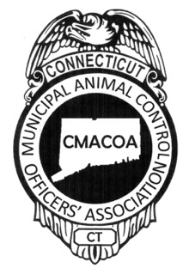
CT Municipal Animal Control
Officers’ Association
P.O. Box 573
Middletown, CT 06457-0573
www.ctaco.org Email: info@ctaco.org

March 13, 2022

Fellow members,

The department of DOAG has implemented new monthly reporting requirements. Each member/agency should have received instructions via their e-license email address. For agencies that do not permit employees their own personal work email address this information is critical to pass on. Should your agency not have received these new DOAG instructions please contact your State ACO promptly at 860-713-2506.

For members that have received DOAG’s new reporting guidelines be sure to communicate the new requirements to your department head. Department heads will assume that the A-26, Municipal Animal Control Officers Report, form will be submitted each month and the new reporting requirements no longer require this form be submitted to the DOAG office.

CMACOA has recognized the value and high importance of this form and has updated the form, renaming it CMACOA A-26. The data collection is very similar to the old A-26 but now includes the specific data DOAG is now mandating as their new monthly reporting requirements. This form is an electronic document or may be printed out and written on. A blank copy of this form is available on the www.CTACO.org site.

CMACOA is strongly advocating that all towns/municipal/regional animal control offices continue with our NEW version of this form, CMACOA A-26. The benefit of this form is its ease to track all impounds on one record. Much data is collected and recorded with each impound. After DOAG’s first attempt to roll out their new reporting requirements, we heard our members loud and clear! Many ACOs wanted to continue with this form’s use. This new form was modified by CMACOA to ensure that every ACO has the ability to uniformly report and track our impounded pets.

CMACOA is hopeful that all municipalities will continue with the CMACOA A-26 form so uniform reporting remains comparable with other towns data. To remain consistent with previous years’ data please continue to keep impound numbers in sequential order beginning at 001, in July of each year and concluding on June 30th the following year. For those newer to the ACO field this sequential numbering follows dog licensing or “Fiscal” year reporting.

Should there be any questions on the use of the CMACOA A-26 form please consult with any CMACOA board member by contacting us personally or by using info@ctaco.org. Should there be any questions on the new DOAG reporting please consult with DOAG directly.

President Vice President Treasurer Secretary
Elease McConnell Ryan Selig Gail Petras Brenda Pflugbeil

